**Wipro Earthian 2017**

Mobility in Urban India

Made By:

Ujjwal Vats

Gaurav Bajpai

(SRM University, Chennai)

Introduction-

The automotive industry has been the major contributor in the country’s GDP(Gross Domestic Product). Factors like favorable topography, increasing income levels, increase in demand has made many automobile manufacturing companies to consider India as their favourite destination.

Ever since the incumbent government came into power their major focus has been on urban as well as rural infrastructure. They have been bringing up new schemes and policies which favour the development of infrastructure. The focus has been on bringing more FDI(Foreign Direct Investment) to the country and on improving manufacturing facilities. Measures such as Goods and Services Tax are way toward bringing different taxes into one single tax regime. The need for good infrastructure for urban life has been supported by the policy of Smart Cities Mission which include some of the major cities of India and to make them smart by 2020.

One of the major objectives of Smart Cities Mission is that it include transforming of urban mobility and infrastructure and to provide variety of public transport options which are reliable and also easily accessible.

Current Scenario:

As per Government of India data automotive sector is one of the highest contributing factor in India’s GDP. It shares about 6.5% in the current scenario and is expected to double i.e. become 12% by 2026. As per Automotive Mission the automobile sector is providing the highest number of job opportunities which is about 10 million and is expected to grow even more. About 32% of the population resides in the urban areas and is expected to grow to 40% by 2030 which contribute to 75% of the GDP off India.

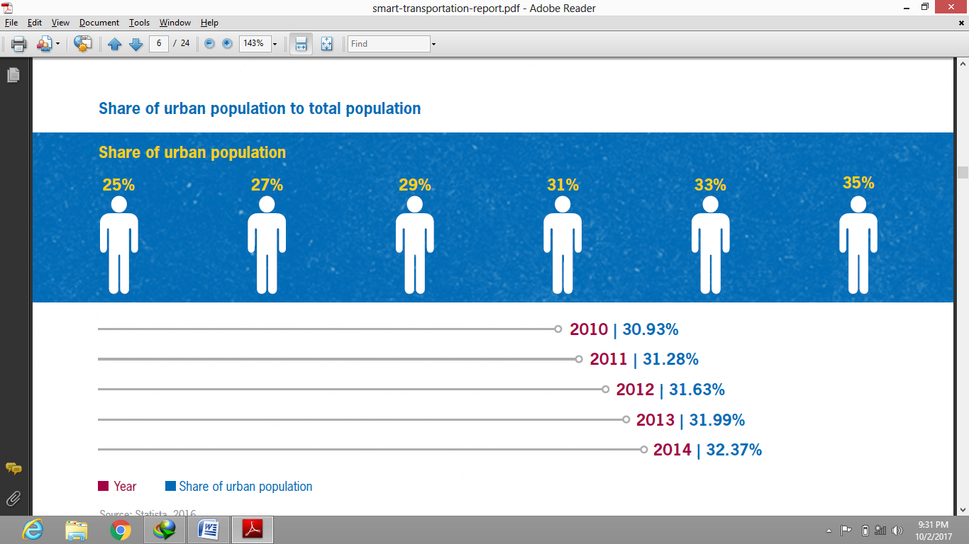

Chennai stands at the crossroad of its history and development. It has a potential to become a global which provides good style of living, medical hub and lots of job opportunities. For this opportunity to become a reality the city has to invest into its infrastructure and capacity building to facilitate development and to improve quality of life to citizens.

Chennai must respond to its transport needs and to address the needs of its citizens well. Failing to do which will lead to viscous cycles. Some solutions though quickly legislated take a lot of time in execution which increases the cost and also frustration among people.

**Trends influencing urban mobility in India**

**Urbanization-**

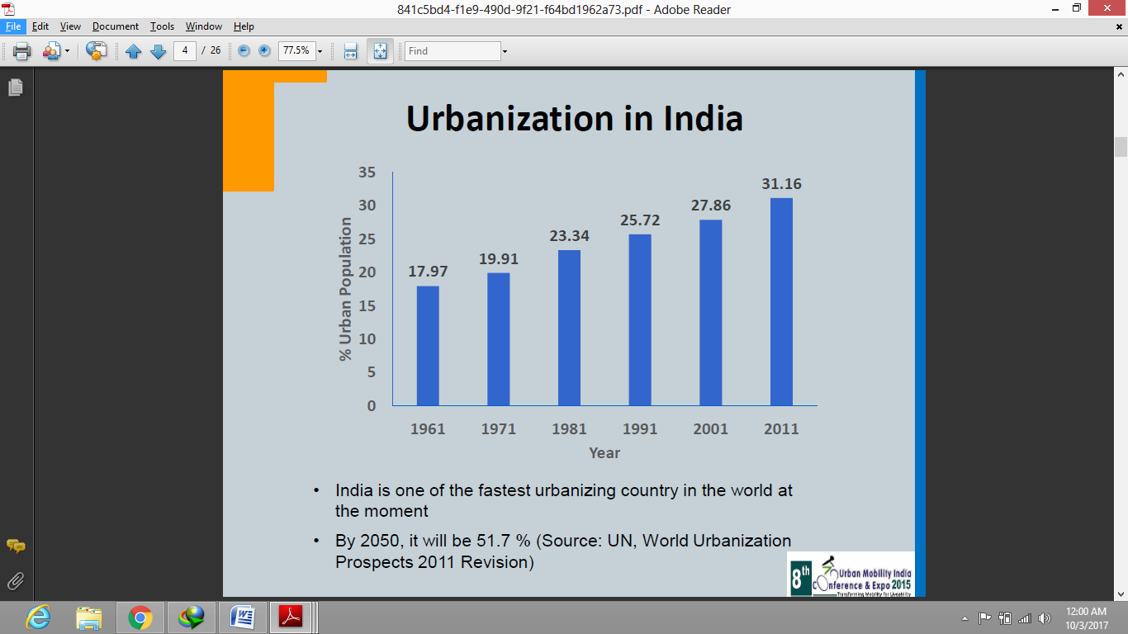

India is one of the fastest growing economies of the world which means there has to be speedy urbanization. The urban population in India was 17% in 1961 and is expected to go till 51.7%. Chennai is no behind in the process. It is known as the medical hub of India. As in 2013 the total vehicle population in Chennai was 3,551,855. Chennai ranks fifth in the total carbon emission among 56 south Asian cities. It also ranks second in the total number of road accidents. The city’s emission levels are much higher than Kolkata and Delhi. This is mostly due to increase in number of vehicles used for commuting and carrying goods. The Metro rail and a dedicated line for BRTS would be a possible solution.

**Motorisation-**

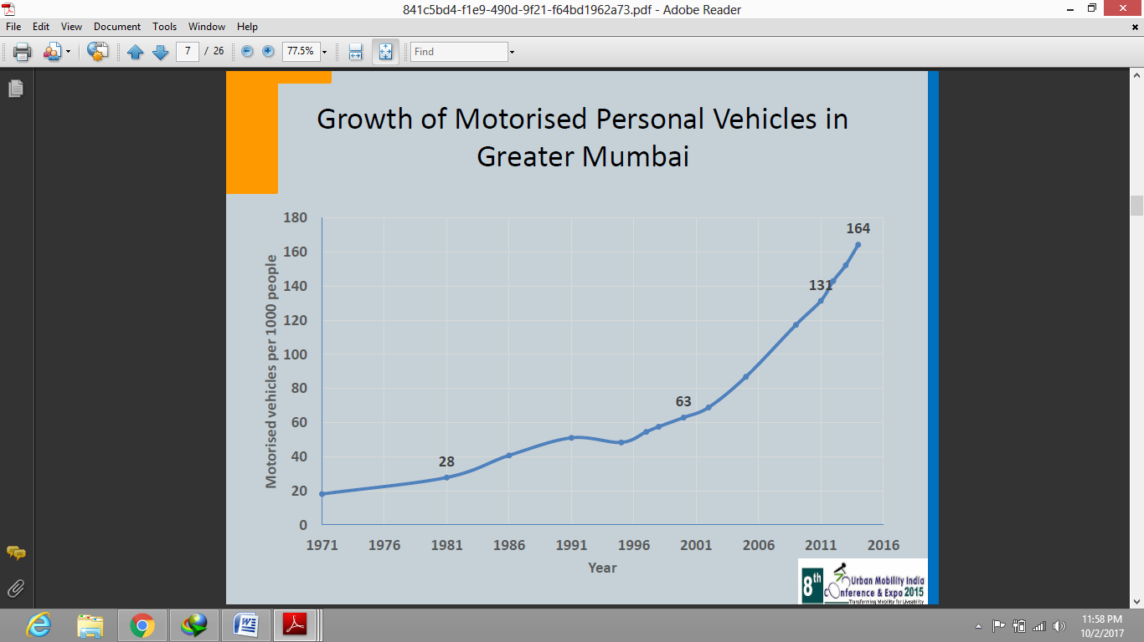

Since 2001 the number of vehicles per 1000 persons have grown significantly. The total registered vehicles in the country has grown at a CAGR (Compounded Annual Growth Rate) of 9.8 percent. The five metro cities have vehicle registration rate at an excess of 500 per 1000 persons.

The Chennai metropolis is expected to become one of the mega cities of the world with population greater than 10 million. Inspite of having a committed schemes for Highways, Outer ring roads, MRTS etc., Chennai is expected to face a greater traffic congestion in the coming years. To improve the situation there has to be a dire need for coming with a comprehensive management plan.

**Dwindling share of Non- motorized transport (NMT)-** Non motorized mode of transport includes walking, cycling, wheelchair travel etc. As cities sprawl, the trend of NMT decreases and people switch over to private mode of transport. NMT modes are perceived to be slow and thereby restricting the speed of travel in cities. The local policies are curtailing the use of NMT over main roads and restricting them in neighbourhood streets. For example, in Chennai you will hardly find cycle rickshaws on main roads as they are slow and time consuming. Bicycle ownership is relatively high in Chennai. The bicycle sale is growing at a rate of 4 percent which good sign. But some issues like bicycle theft, fear of safety, lack of infrastructure like poor parking spaces and cycle tracks in the city are some of the factors responsible for dwindling share of NMT.

**Urban Transport problems-**

**Road congestion:** As the population increase, the average travel distance and time will also increase as there is a direct relation between the two. Traffic congestion is a policy issue which demands an immediate response from the concerned to strike a balance between urbanization and urban mobility. Many policies have been implemented on the issue but none have actually yielded to any desired outcomes. Urban congestion is broadly defined as increase in demand of travel over its supply.

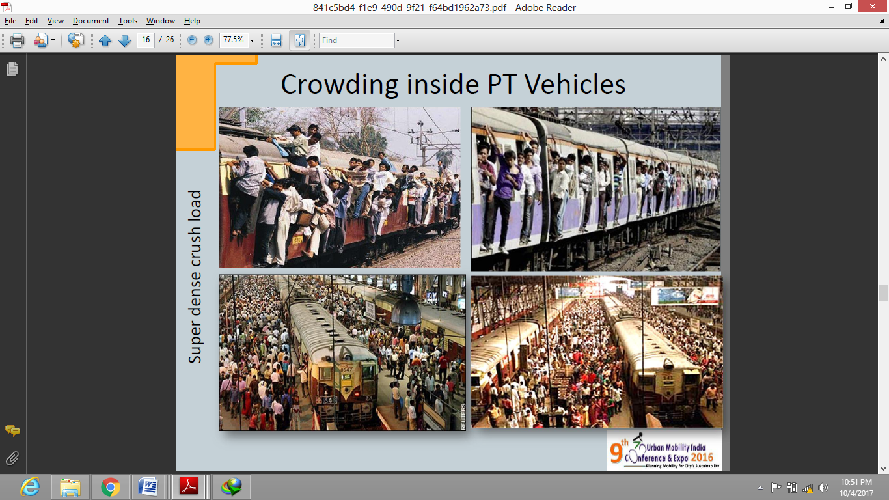

Clearly, there is a need to improve the urban infrastructure and organizational structure that are needed for a city to function well in an urban area.

**Parking Problems-**

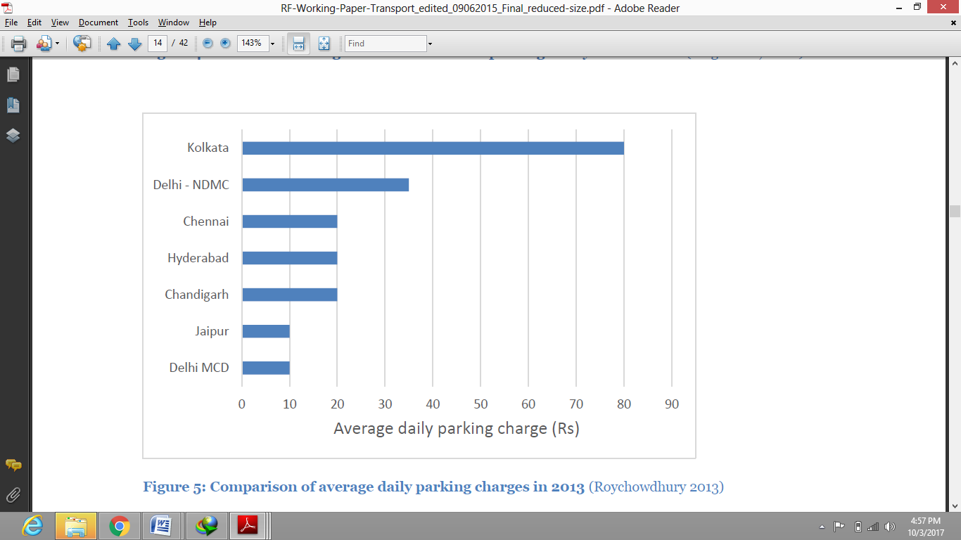

The acute shortage of parking spaces a major problem people face in their daily lives. This problem is even worse in smaller cities. Even in Chennai parking problem is a big concern. The city’s vehicular population is on the rise and Metropolitan Development Authorities are struggling hard to accommodate the present vehicular population. Apartments which were constructed 15 years ago are facing more problems as their structure is too weak to handle the weight of increasing cars and also demand to be reconstructed so as to increase the parking spaces. On-street parking is still preferred because it is either free or lower than off-street parking. Even if city invests in multi-level car parking it is not expected to recover the construction costs.

**Air Pollution:**

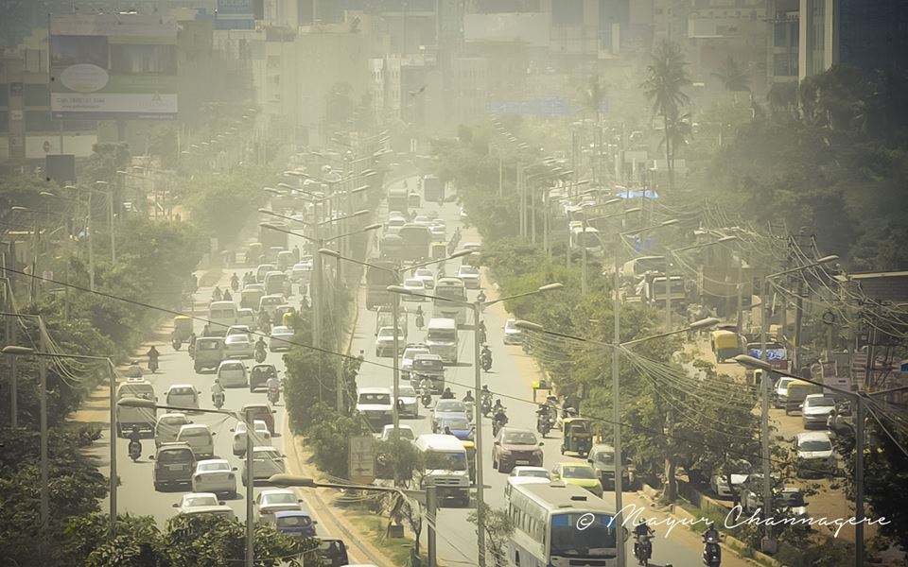

The severity of air pollution is judged by CPCB (Central Pollution Control Board). Air pollution in Indian cities is the fifth leading cause of death in India. Toxic air and its serious ill effects are compromising the urban life in India. It is crystal clear that our government is moving towards alternative clean fuels. While the industry demands a stable policy regime from the government, to which the government is already working by curbing imports so that companies do not complain in future for left over stock to switch over to non polluting engines.

According to Centre for Science and Environment the petrochemical smog is one of the main reason for pollution in urban cities. High levels of Nitrogen Dioxide leads to several health issues like respiratory diseases. This can cause issues like coughing, asthma, bronchitis. Car pool, cycles , walking to work will only reduce pollution level.

**Deteriorating Road Safety-**

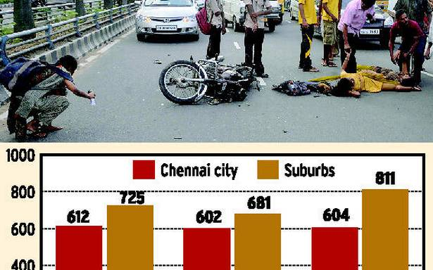

The number of fatalities is increasing on roads as number of motorized and non-motorised vehicles continue to grow. While attempts have been made to save people in cars, less has been done for cyclists, pedestrians etc. The main reason has been inequitable distribution of roads for pedestrians, cyclists, cars, trucks. Currently in India roads are not designed for walking or cycling.

**Challenges-**

**Gaps in laws and regulations-**

Presently our basic infrastructure lacks a good policy that is working efficiently to improve transportation needs. The policies are very well legislated in the parliament but the only problem which pulls it back is its implementation. The Supreme Court also could not hold itself calm and had to jump into the issue. The latest ban of liquor shops on national highways is a very good example of it. Also the overcrowding in local trains where daily many risk their lives by travelling on the roofs is still not addressed. A combined approach is needed over this where both government and the citizens cooperate with each other thus making the easier to implement and regulated.

Currently, the government has launched efficient schemes to improve urban mobility like-

1. **ATAL MISSION FOR REJUVENATION AND URBAN TRANSFORMATION**(**AMRUT**).
2. **Smart City Mission.**
3. **Faster Adoption and Manufacturing of Hybrid and Electric vehicles(FAME).**

**Fragmented Institutional Framework-**

Urban Development requires several functions to be performed to get best results. In constitution of India the urban transport is a state subject under Seventh schedule (Article 246) which gives the centre a clean escape. But unless both work together the process won’t work. The Government of India, Rules 1961 gave the responsibility of urban transformation to Ministry of Transport. In the state level State Transport Department (STD) and Urban Development Department (UDD) have the charge of regulating transport. Unfortunately, there is no coordination between vertical or horizontal level agencies which is restricting the process. For example, in Chennai Ministry of Railways put down the order for making new local trains for urban development due to financial constraints to which Ministry of urban Development took over the charge without having much of resources.

**Distorted Land Markets-**

Soaring land prices in India has reduced affordability of land. This is happening because the land availability is getting very limited thus in economic terms when supply is less and demand is more the prices increase. So it is becoming a challenge for the government to implement new projects as the amount to be compensated to people on taking their land for construction is increasing. Also no space is left to build new roads to reduce the traffic on the older ones. The restrictive policies like maximum permissible height of buildings are one of the reasons of increasing land prices. This reduces the per capita floor income, encourages sprawling which increases the infrastructure cost.

A series of policy reforms are needed to solve the issue. Firstly, the registration cost and stamp duty should be lowered by 2-4 percent and also the process should be quick and not left for weeks.

The urban master plans should use varying Floor Space Index (FSI).

**Human Resource Challenges-** The urban transportation is a complex system as it requires efforts from central, state, local levels. Unfortunately, there are only a few officials with clear understanding of the urban issues and how to effectively deal with it. This is happening because there are no good job opportunities in urban sector given by the government on central or state level. Also, improper training skills of the officers is a major problem. Training workshops should be organized by the centre to update the officials with the latest urban development in the rest of the world. Due to increasing protectionism in the entire world, our government should come up with more number of vacancies in urban sector as it will give employment to our youth and also increase the infrastructure and GDP of India.

**Inefficiencies in Bus services-**

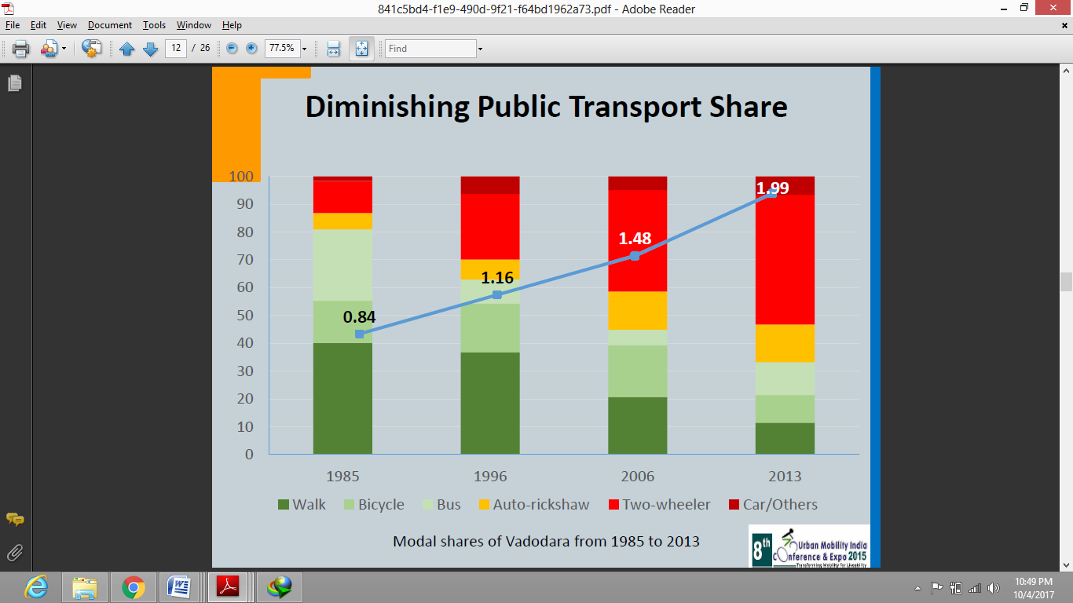

Since decades the poorer section of the society rely on bus services to travel from one place to another. But the bus services should be for all and not just for poor. But one of the main reasons why buses cannot give competition to private vehicles is that the condition of government buses is very poor and the buses get stuck in jams. This problem can be solved to an extent by providing dedicated lines for buses only, which needs a comprehensive planning and better implementation. Chennai can provide world class transportation to its suburbs while also encouraging transit options.

**Solutions-**

Technological investments are helping users offer many useful features. To catalyse integrated mobility and accessibility that could be applied locally and applied in the marketplace. Also government is working hard to address the issue efficiently. Until the congestion problem is solved the things won’t move faster and thus restrict the growth of the country.

Other countries are showing their interest to supply clean fuel and technology to use the same. Recently Japan signed a deal with India to provide Bullet train to India which is fast and also produces no pollution as it works on magnetic technology.

The Tamil Nadu state government has made it compulsory to carry original documents while driving and has issued strict action laws on failing to do so. This is a great move to reduce accidents on roads as most of the accidents are caused when the driver is a minor. Also annually Rs 2 crores additionally will be spent to conduct awareness program.

Some solutions to the urban transportation that are being used abroad and will be used in India are as follows:

1. **Multi Level Car Parking-**

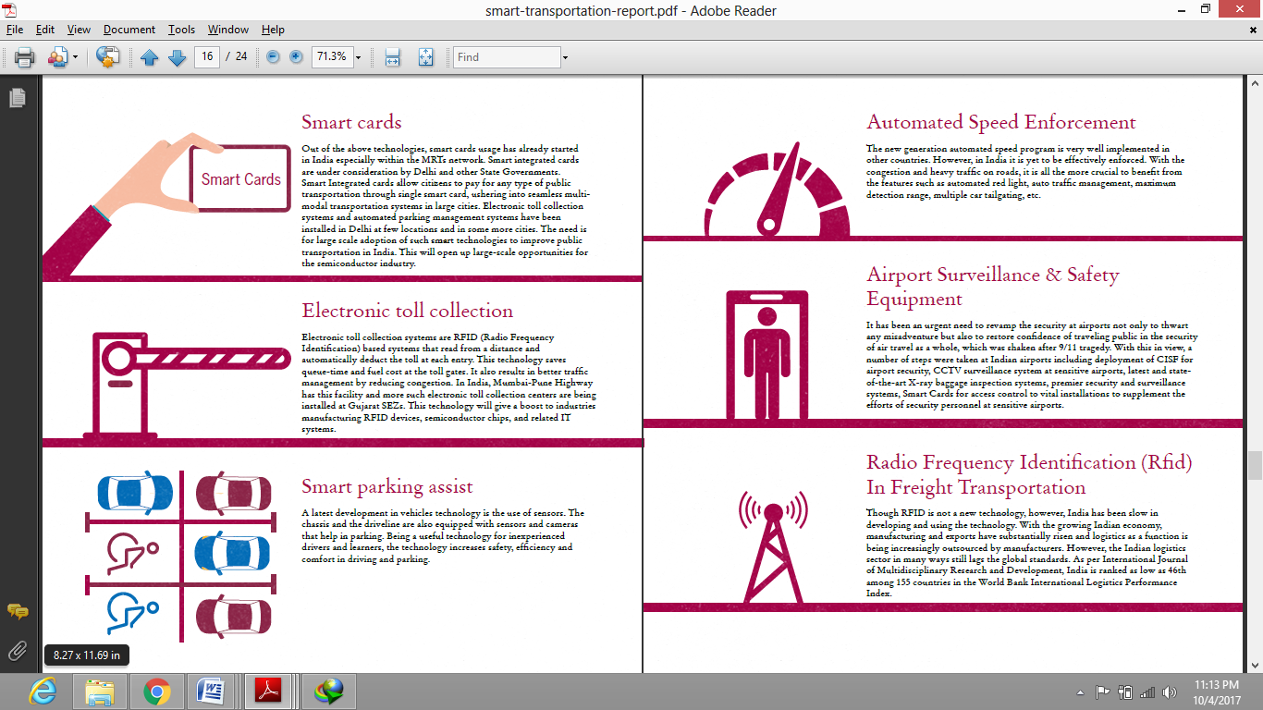

This system displays the data of empty parking lots through a public electronic sign board. The benefits are minimal land use, multi sensors and safety devices, easy entry and exit and also has low maintenance costs.

1. **Smart Cards-**



These are already in use in some of the states in India including Delhi. A smart card allows payment for any mode of public transport using a single card. The need is for a wide scale adoption of this technology in the country as it will be convenient to people and also boost the semi conductor industry.

1. **Automated Speed Enforcement-**



This technology is working well in other countries and is still to be well enforced in India. With daily traffic and congestion, people are more likely to benefit with automatic traffic light, auto traffic management, maximum detection range, multiple car tailgating etc.

Some solutions at city level are-

1. Passenger movement data could be obtained using cell phones. This will help in monitoring traffic in particular areas by supplying sufficient feeder buses.
2. Cycle rentals in and around Chennai should be developed to travel short distances.
3. In places like Koyembedu and Anna Nagar cab sharing services should be increased as it will reduce fuel consumption and also cost of booking a private cab.
4. Wire free buses should be provided to enable work while travelling.
5. Feeder buses should be provided around the IT corridor as the actual congestion is seen near these areas only.

**Conclusion-**

India remains no different from the use and implementation of smart transportation. Existing and upcoming metro

rail network around our capital cities is just a start. India has already chalked out a plan to have electric cars for all by

2030.

It is likely that the government will have to increase this allocation to improve the attractiveness and acceptance

of the hybrid vehicles. A combination of strong policies, public and private sector investments and public

awareness will bring the desired change for implementing and executing the dream of smart transportation in the

country.